**MP Assignment**

**MainActivity.java**

**package com.example.shopping;**

**import androidx.annotation.NonNull;**

**import androidx.appcompat.app.AppCompatActivity;**

**import android.content.Intent;**

**import android.os.Bundle;**

**import android.view.Menu;**

**import android.view.MenuItem;**

**public class MainActivity extends AppCompatActivity {**

**@Override**

**protected void onCreate(Bundle savedInstanceState) {**

**super.onCreate(savedInstanceState);**

**setContentView(R.layout.activity_main);**

**}**

**@Override**

**public boolean onCreateOptionsMenu(Menu menu) {**

**getMenuInflater().inflate(R.menu.account, menu);**

**return true;**

**}**

**@Override**

**public boolean onOptionsItemSelected(@NonNull MenuItem item) {**

**int id = item.getItemId();**

**if (id == R.id.login) {**

**Intent i = new Intent(getApplicationContext(), Login.class);**

**startActivity(i);**

**}**

**if (id == R.id.register) {**

**Intent r = new Intent(getApplicationContext(), Register.class);**

**startActivity(r);**

**}**

**return super.onOptionsItemSelected(item);**

**}**

**}**

**MainActivity.xml**

**<?xml version="1.0" encoding="utf-8"?>**

**<androidx.constraintlayout.widget.ConstraintLayout xmlns:android="http://schemas.android.com/apk/res/android"**

**xmlns:app="http://schemas.android.com/apk/res-auto"**

**xmlns:tools="http://schemas.android.com/tools"**

**android:layout_width="match_parent"**

**android:layout_height="match_parent"**

**tools:context=".MainActivity">**

**<ImageView**

**android:id="@+id/imageView"**

**android:layout_width="wrap_content"**

**android:layout_height="wrap_content"**

**app:srcCompat="@drawable/main"**

**tools:layout_editor_absoluteX="0dp"**

**tools:layout_editor_absoluteY="0dp" />**

**</androidx.constraintlayout.widget.ConstraintLayout>**

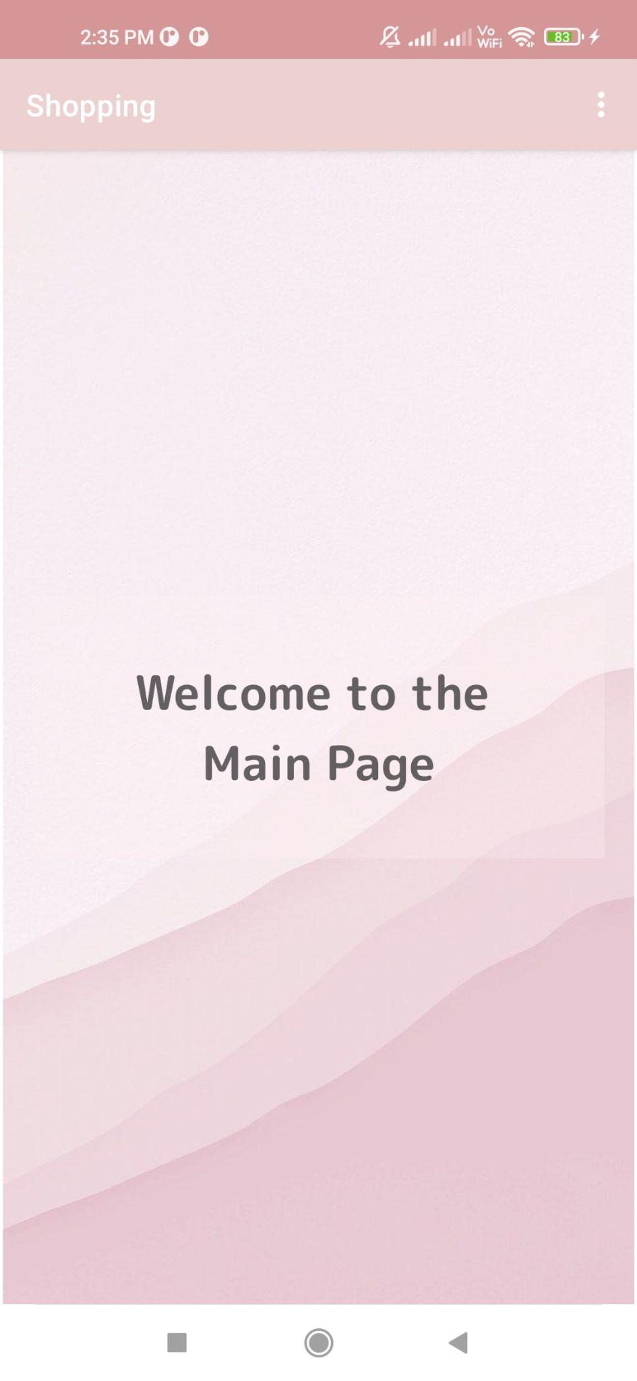

**Menu.xml**

**<?xml version="1.0" encoding="utf-8"?>**

**<menu xmlns:android="http://schemas.android.com/apk/res/android">**

**<item**

**android:id="@+id/cart"**

**android:title="Cart" />**

**<item**

**android:id="@+id/bill"**

**android:title="Bill" />**

**<item**

**android:id="@+id/product"**

**android:title="Show Product" />**

**</menu>**

**Account.xml**

**<?xml version="1.0" encoding="utf-8"?>**

**<menu xmlns:android="http://schemas.android.com/apk/res/android">**

**<item**

**android:id="@+id/register"**

**android:title="Register" />**

**<item**

**android:id="@+id/login"**

**android:title="Login" />**

**</menu>**

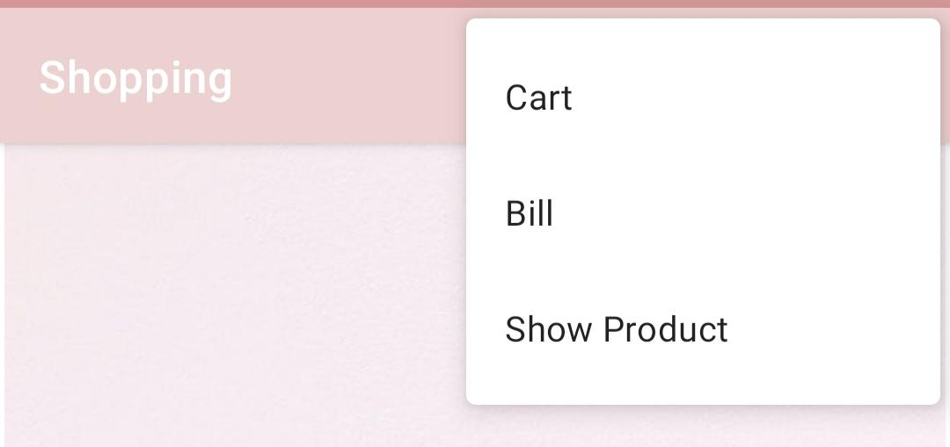

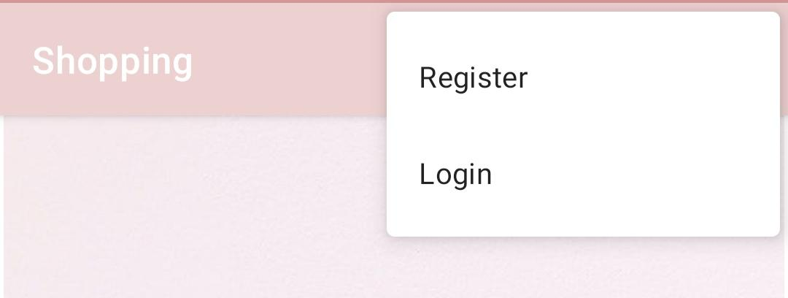

**Register.java**

**package com.example.shopping;**

**import androidx.annotation.NonNull;**

**import androidx.appcompat.app.AppCompatActivity;**

**import android.content.Context;**

**import android.content.Intent;**

**import android.database.sqlite.SQLiteDatabase;**

**import android.os.Bundle;**

**import android.view.Menu;**

**import android.view.MenuItem;**

**import android.view.View;**

**import android.widget.EditText;**

**import android.widget.ImageButton;**

**import android.widget.Toast;**

**public class Register extends AppCompatActivity {**

**EditText email, username, password;**

**ImageButton button;**

**SQLiteDatabase db;**

**@Override**

**protected void onCreate(Bundle savedInstanceState) {**

**super.onCreate(savedInstanceState);**

**setContentView(R.layout.activity_register);**

**username = findViewById(R.id.register_username);**

**email = findViewById(R.id.register_email);**

**password = findViewById(R.id.register_password);**

**button = findViewById(R.id.register_button);**

**db = openOrCreateDatabase("Mydata", Context.MODE_PRIVATE,null);**

**db.execSQL("Create Table If Not Exists userinfo(username varchar, password varchar, email varchar);");**

**button.setOnClickListener(new View.OnClickListener() {**

**@Override**

**public void onClick(View view) {**

**try {**

**String q = "Insert into userinfo Values('"+username.getText().toString()+"','"+password.getText().toString()+"','"+email.getText().toString()+"')";**

**db.execSQL(q);**

**Toast.makeText(getApplicationContext(),"user " + username.getText()+ " Added!", Toast.LENGTH_LONG).show();**

**username.getText().clear();**

**password.getText().clear();**

**email.getText().clear();**

**Intent login = new Intent(getApplicationContext(), Login.class);**

**startActivity(login);**

**}**

**catch (Exception e){**

**}**

**}**

**});**

**}**

**@Override**

**public boolean onCreateOptionsMenu(Menu menu) {**

**getMenuInflater().inflate(R.menu.account, menu);**

**return true;**

**}**

**@Override**

**public boolean onOptionsItemSelected(@NonNull MenuItem item) {**

**int id = item.getItemId();**

**if (id == R.id.login) {**

**Intent i = new Intent(getApplicationContext(), Login.class);**

**startActivity(i);**

**}**

**if (id == R.id.register) {**

**Intent r = new Intent(getApplicationContext(), Register.class);**

**startActivity(r);**

**}**

**return super.onOptionsItemSelected(item);**

**}**

**}**

**Register.xml**

**<?xml version="1.0" encoding="utf-8"?>**

**<androidx.constraintlayout.widget.ConstraintLayout xmlns:android="http://schemas.android.com/apk/res/android"**

**xmlns:app="http://schemas.android.com/apk/res-auto"**

**xmlns:tools="http://schemas.android.com/tools"**

**android:layout_width="match_parent"**

**android:layout_height="match_parent"**

**tools:context=".Register">**

**<ImageView**

**android:id="@+id/imageView4"**

**android:layout_width="wrap_content"**

**android:layout_height="wrap_content"**

**app:srcCompat="@drawable/register"**

**tools:layout_editor_absoluteX="0dp"**

**tools:layout_editor_absoluteY="0dp" />**

**<EditText**

**android:id="@+id/register_username"**

**android:layout_width="wrap_content"**

**android:layout_height="wrap_content"**

**android:ems="10"**

**android:inputType="textPersonName"**

**app:layout_constraintBottom_toBottomOf="parent"**

**app:layout_constraintEnd_toEndOf="parent"**

**app:layout_constraintHorizontal_bias="0.582"**

**app:layout_constraintStart_toStartOf="parent"**

**app:layout_constraintTop_toTopOf="parent"**

**app:layout_constraintVertical_bias="0.355" />**

**<EditText**

**android:id="@+id/register_email"**

**android:layout_width="wrap_content"**

**android:layout_height="wrap_content"**

**android:ems="10"**

**android:inputType="textEmailAddress"**

**app:layout_constraintBottom_toBottomOf="parent"**

**app:layout_constraintEnd_toEndOf="parent"**

**app:layout_constraintHorizontal_bias="0.582"**

**app:layout_constraintStart_toStartOf="parent"**

**app:layout_constraintTop_toTopOf="parent"**

**app:layout_constraintVertical_bias="0.446" />**

**<EditText**

**android:id="@+id/register_password"**

**android:layout_width="wrap_content"**

**android:layout_height="wrap_content"**

**android:ems="10"**

**android:inputType="textPassword"**

**app:layout_constraintBottom_toBottomOf="parent"**

**app:layout_constraintEnd_toEndOf="parent"**

**app:layout_constraintHorizontal_bias="0.582"**

**app:layout_constraintStart_toStartOf="parent"**

**app:layout_constraintTop_toTopOf="parent"**

**app:layout_constraintVertical_bias="0.537" />**

**<ImageButton**

**android:id="@+id/register_button"**

**android:layout_width="wrap_content"**

**android:layout_height="wrap_content"**

**android:backgroundTint="#00FFFFFF"**

**app:layout_constraintBottom_toBottomOf="parent"**

**app:layout_constraintEnd_toEndOf="parent"**

**app:layout_constraintHorizontal_bias="0.497"**

**app:layout_constraintStart_toStartOf="parent"**

**app:layout_constraintTop_toTopOf="parent"**

**app:layout_constraintVertical_bias="0.699"**

**app:srcCompat="@drawable/submit" />**

**</androidx.constraintlayout.widget.ConstraintLayout>**

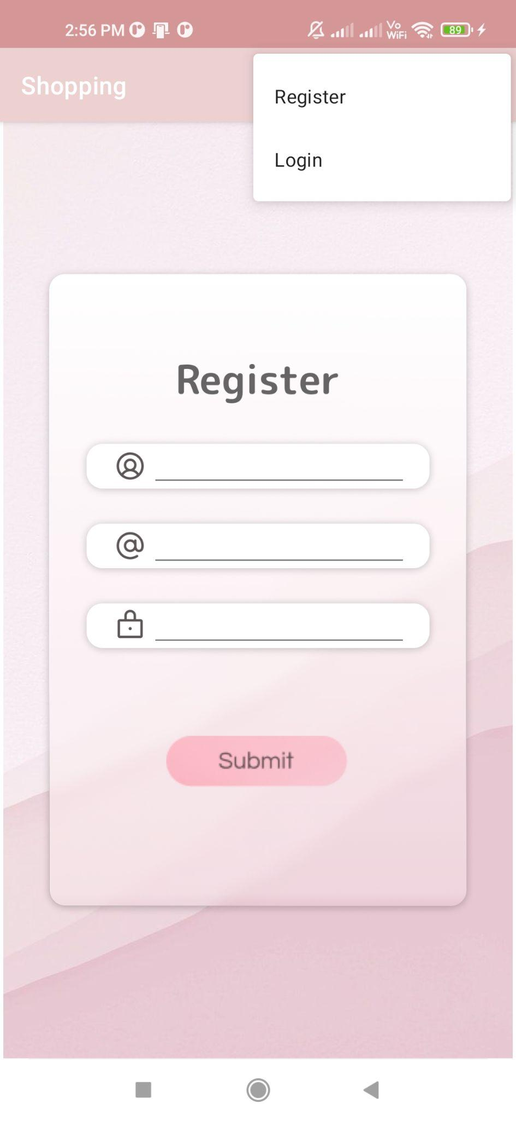

**Login.java**

**package com.example.shopping;**

**import androidx.annotation.NonNull;**

**import androidx.appcompat.app.AppCompatActivity;**

**import android.content.Context;**

**import android.content.Intent;**

**import android.database.Cursor;**

**import android.database.sqlite.SQLiteDatabase;**

**import android.os.Bundle;**

**import android.view.Menu;**

**import android.view.MenuItem;**

**import android.view.View;**

**import android.widget.EditText;**

**import android.widget.ImageButton;**

**import android.widget.Toast;**

**public class Login extends AppCompatActivity {**

**EditText username, password;**

**ImageButton button;**

**SQLiteDatabase db;**

**Cursor cr;**

**@Override**

**protected void onCreate(Bundle savedInstanceState) {**

**super.onCreate(savedInstanceState);**

**setContentView(R.layout.activity_login);**

**username = findViewById(R.id.login_username);**

**password = findViewById(R.id.login_password);**

**button = findViewById(R.id.login_button);**

**db = openOrCreateDatabase("Mydata", Context.MODE_PRIVATE,null);**

**db.execSQL("Create Table If Not Exists userinfo(username varchar, password varchar, email varchar);");**

**button.setOnClickListener(new View.OnClickListener() {**

**@Override**

**public void onClick(View view) {**

**String querys = "select * from userinfo";**

**cr = db.rawQuery(querys, null);**

**String U = username.getText().toString();**

**String P = password.getText().toString();**

**int RowCount = cr.getCount();**

**cr.moveToFirst();**

**for (int i = 0; i < RowCount; i++) {**

**boolean ChanceU = U.equals(cr.getString(0));**

**boolean ChanceP = P.equals(cr.getString(1));**

**if (ChanceU == true && ChanceP == true) {**

**Toast.makeText(getApplicationContext(), "Welcome " + username.getText(), Toast.LENGTH_LONG).show();**

**Intent Cat = new Intent(getApplicationContext(), Category.class);**

**startActivity(Cat);**

**break;**

**}**

**cr.moveToNext();**

**}**

**}**

**});**

**}**

**@Override**

**public boolean onCreateOptionsMenu(Menu menu) {**

**getMenuInflater().inflate(R.menu.account, menu);**

**return true;**

**}**

**@Override**

**public boolean onOptionsItemSelected(@NonNull MenuItem item) {**

**int id = item.getItemId();**

**if (id == R.id.login) {**

**Intent i = new Intent(getApplicationContext(), Login.class);**

**startActivity(i);**

**}**

**if (id == R.id.register) {**

**Intent r = new Intent(getApplicationContext(), Register.class);**

**startActivity(r);**

**}**

**return super.onOptionsItemSelected(item);**

**}**

**}**

**Login.xml**

**<?xml version="1.0" encoding="utf-8"?>**

**<androidx.constraintlayout.widget.ConstraintLayout xmlns:android="http://schemas.android.com/apk/res/android"**

**xmlns:app="http://schemas.android.com/apk/res-auto"**

**xmlns:tools="http://schemas.android.com/tools"**

**android:layout_width="match_parent"**

**android:layout_height="match_parent"**

**tools:context=".Login">**

**<ImageView**

**android:id="@+id/imageView2"**

**android:layout_width="wrap_content"**

**android:layout_height="wrap_content"**

**app:srcCompat="@drawable/loginpage"**

**tools:layout_editor_absoluteX="0dp"**

**tools:layout_editor_absoluteY="0dp" />**

**<EditText**

**android:id="@+id/login_username"**

**android:layout_width="wrap_content"**

**android:layout_height="wrap_content"**

**android:ems="10"**

**android:inputType="textPersonName"**

**app:layout_constraintBottom_toBottomOf="parent"**

**app:layout_constraintEnd_toEndOf="parent"**

**app:layout_constraintHorizontal_bias="0.582"**

**app:layout_constraintStart_toStartOf="parent"**

**app:layout_constraintTop_toTopOf="parent"**

**app:layout_constraintVertical_bias="0.399" />**

**<EditText**

**android:id="@+id/login_password"**

**android:layout_width="wrap_content"**

**android:layout_height="wrap_content"**

**android:ems="10"**

**android:inputType="textPassword"**

**app:layout_constraintBottom_toBottomOf="parent"**

**app:layout_constraintEnd_toEndOf="parent"**

**app:layout_constraintHorizontal_bias="0.577"**

**app:layout_constraintStart_toStartOf="parent"**

**app:layout_constraintTop_toTopOf="parent" />**

**<ImageButton**

**android:id="@+id/login_button"**

**android:layout_width="wrap_content"**

**android:layout_height="wrap_content"**

**android:backgroundTint="#00FFFFFF"**

**app:layout_constraintBottom_toBottomOf="parent"**

**app:layout_constraintEnd_toEndOf="parent"**

**app:layout_constraintHorizontal_bias="0.497"**

**app:layout_constraintStart_toStartOf="parent"**

**app:layout_constraintTop_toTopOf="parent"**

**app:layout_constraintVertical_bias="0.673"**

**app:srcCompat="@drawable/loginb" />**

**</androidx.constraintlayout.widget.ConstraintLayout>**

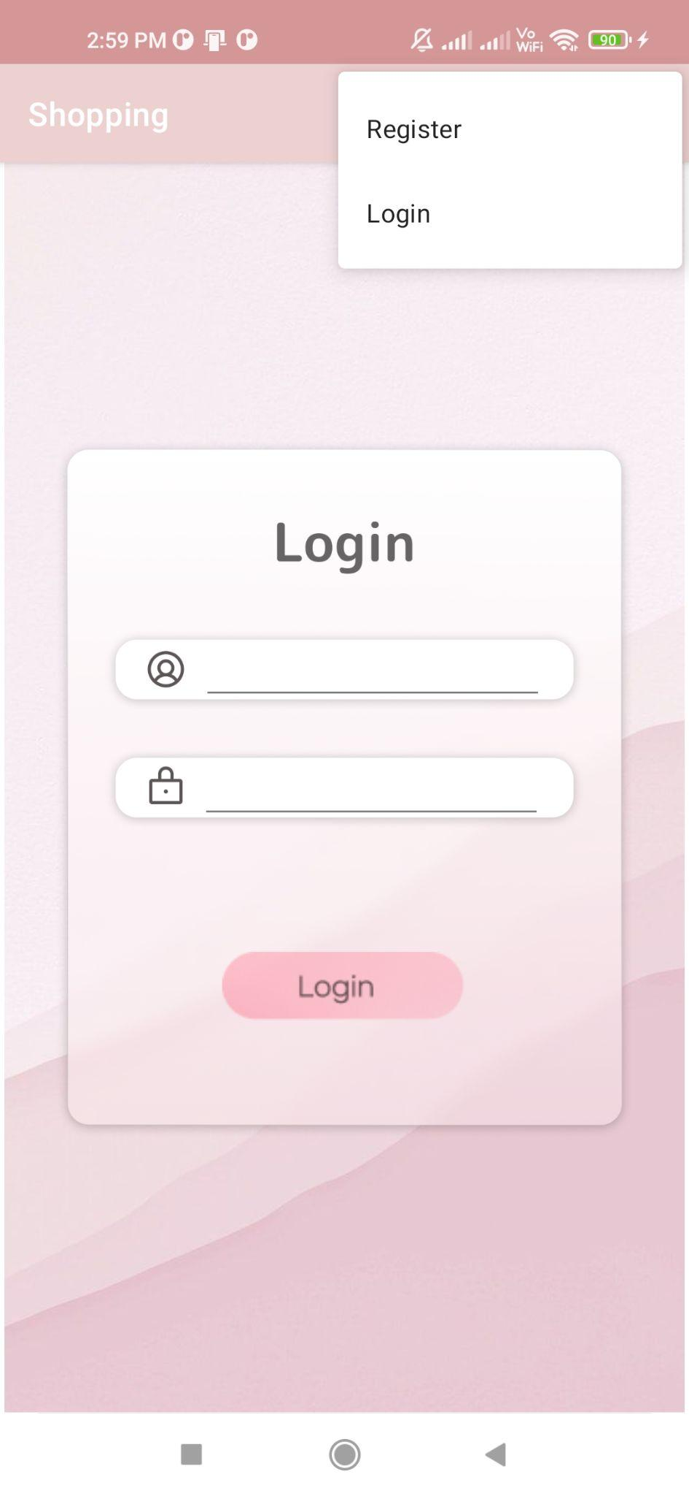

**Category.java**

**package com.example.shopping;**

**import androidx.annotation.NonNull;**

**import androidx.appcompat.app.AppCompatActivity;**

**import android.content.Intent;**

**import android.os.Bundle;**

**import android.view.Menu;**

**import android.view.MenuItem;**

**import android.view.View;**

**import android.widget.AdapterView;**

**import android.widget.ArrayAdapter;**

**import android.widget.ImageButton;**

**import android.widget.Spinner;**

**public class Category extends AppCompatActivity {**

**Spinner spinner;**

**ImageButton button;**

**@Override**

**protected void onCreate(Bundle savedInstanceState) {**

**super.onCreate(savedInstanceState);**

**setContentView(R.layout.activity_category);**

**String[] cat = {"Role-playing","Shooters (FPS and TPS)","Real-Time strategy ","MMORPG"};**

**spinner = findViewById(R.id.product_spinner);**

**button = findViewById(R.id.cat_button);**

**ArrayAdapter<String> c=new ArrayAdapter<String>(getApplicationContext(), android.R.layout.simple_spinner_item, cat);**

**c.setDropDownViewResource(android.R.layout.simple_spinner_dropdown_item);**

**spinner.setAdapter(c);**

**spinner.setOnItemSelectedListener(new AdapterView.OnItemSelectedListener() {**

**@Override**

**public void onItemSelected(AdapterView<?> adapterView, View view, int i, long l) {**

**if (i == 0){**

**button.setOnClickListener(new View.OnClickListener() {**

**@Override**

**public void onClick(View view) {**

**Intent i = new Intent(getApplicationContext(), qnty.class);**

**String n = "1" ;**

**i.putExtra("list",n);**

**startActivity(i);**

**}**

**});**

**}**

**if (i==1){**

**button.setOnClickListener(new View.OnClickListener() {**

**@Override**

**public void onClick(View view) {**

**Intent i = new Intent(getApplicationContext(), qnty.class);**

**String n = "2";**

**i.putExtra("list",n);**

**startActivity(i);**

**}**

**});**

**}**

**if (i==2){**

**button.setOnClickListener(new View.OnClickListener() {**

**@Override**

**public void onClick(View view) {**

**Intent i = new Intent(getApplicationContext(), qnty.class);**

**String n = "3";**

**i.putExtra("list",n);**

**startActivity(i);**

**}**

**});**

**}**

**if (1==3){**

**button.setOnClickListener(new View.OnClickListener() {**

**@Override**

**public void onClick(View view) {**

**Intent i = new Intent(getApplicationContext(), qnty.class);**

**String n = "4";**

**i.putExtra("list",n);**

**startActivity(i);**

**}**

**});**

**}**

**}**

**@Override**

**public void onNothingSelected(AdapterView<?> adapterView) {**

**}**

**});**

**}**

**@Override**

**public boolean onCreateOptionsMenu(Menu menu) {**

**getMenuInflater().inflate(R.menu.menu, menu);**

**return true;**

**}**

**@Override**

**public boolean onOptionsItemSelected(@NonNull MenuItem item) {**

**int id = item.getItemId();**

**if (id == R.id.cart) {**

**Intent s = new Intent(getApplicationContext(), qnty.class);**

**startActivity(s);**

**}**

**if (id == R.id.bill) {**

**Intent u = new Intent(getApplicationContext(), Bill.class);**

**startActivity(u);**

**}**

**if (id == R.id.product) {**

**Intent d = new Intent(getApplicationContext(), Category.class);**

**startActivity(d);**

**}**

**return super.onOptionsItemSelected(item);**

**}**

**}**

**Category.java**

**<?xml version="1.0" encoding="utf-8"?>**

**<androidx.constraintlayout.widget.ConstraintLayout xmlns:android="http://schemas.android.com/apk/res/android"**

**xmlns:app="http://schemas.android.com/apk/res-auto"**

**xmlns:tools="http://schemas.android.com/tools"**

**android:layout_width="match_parent"**

**android:layout_height="match_parent"**

**tools:context=".Category">**

**<ImageView**

**android:id="@+id/imageView3"**

**android:layout_width="wrap_content"**

**android:layout_height="wrap_content"**

**app:srcCompat="@drawable/cat"**

**tools:layout_editor_absoluteX="0dp"**

**tools:layout_editor_absoluteY="0dp" />**

**<Spinner**

**android:id="@+id/product_spinner"**

**android:layout_width="161dp"**

**android:layout_height="35dp"**

**android:popupBackground="#F1BBC4"**

**app:layout_constraintBottom_toBottomOf="parent"**

**app:layout_constraintEnd_toEndOf="parent"**

**app:layout_constraintHorizontal_bias="1.0"**

**app:layout_constraintStart_toStartOf="parent"**

**app:layout_constraintTop_toTopOf="parent"**

**app:layout_constraintVertical_bias="0.405" />**

**<ImageButton**

**android:id="@+id/cat_button"**

**android:layout_width="wrap_content"**

**android:layout_height="wrap_content"**

**android:backgroundTint="#00FFFFFF"**

**app:layout_constraintBottom_toBottomOf="parent"**

**app:layout_constraintEnd_toEndOf="parent"**

**app:layout_constraintHorizontal_bias="0.497"**

**app:layout_constraintStart_toStartOf="parent"**

**app:layout_constraintTop_toTopOf="parent"**

**app:layout_constraintVertical_bias="0.572"**

**app:srcCompat="@drawable/submit" />**

**</androidx.constraintlayout.widget.ConstraintLayout>**

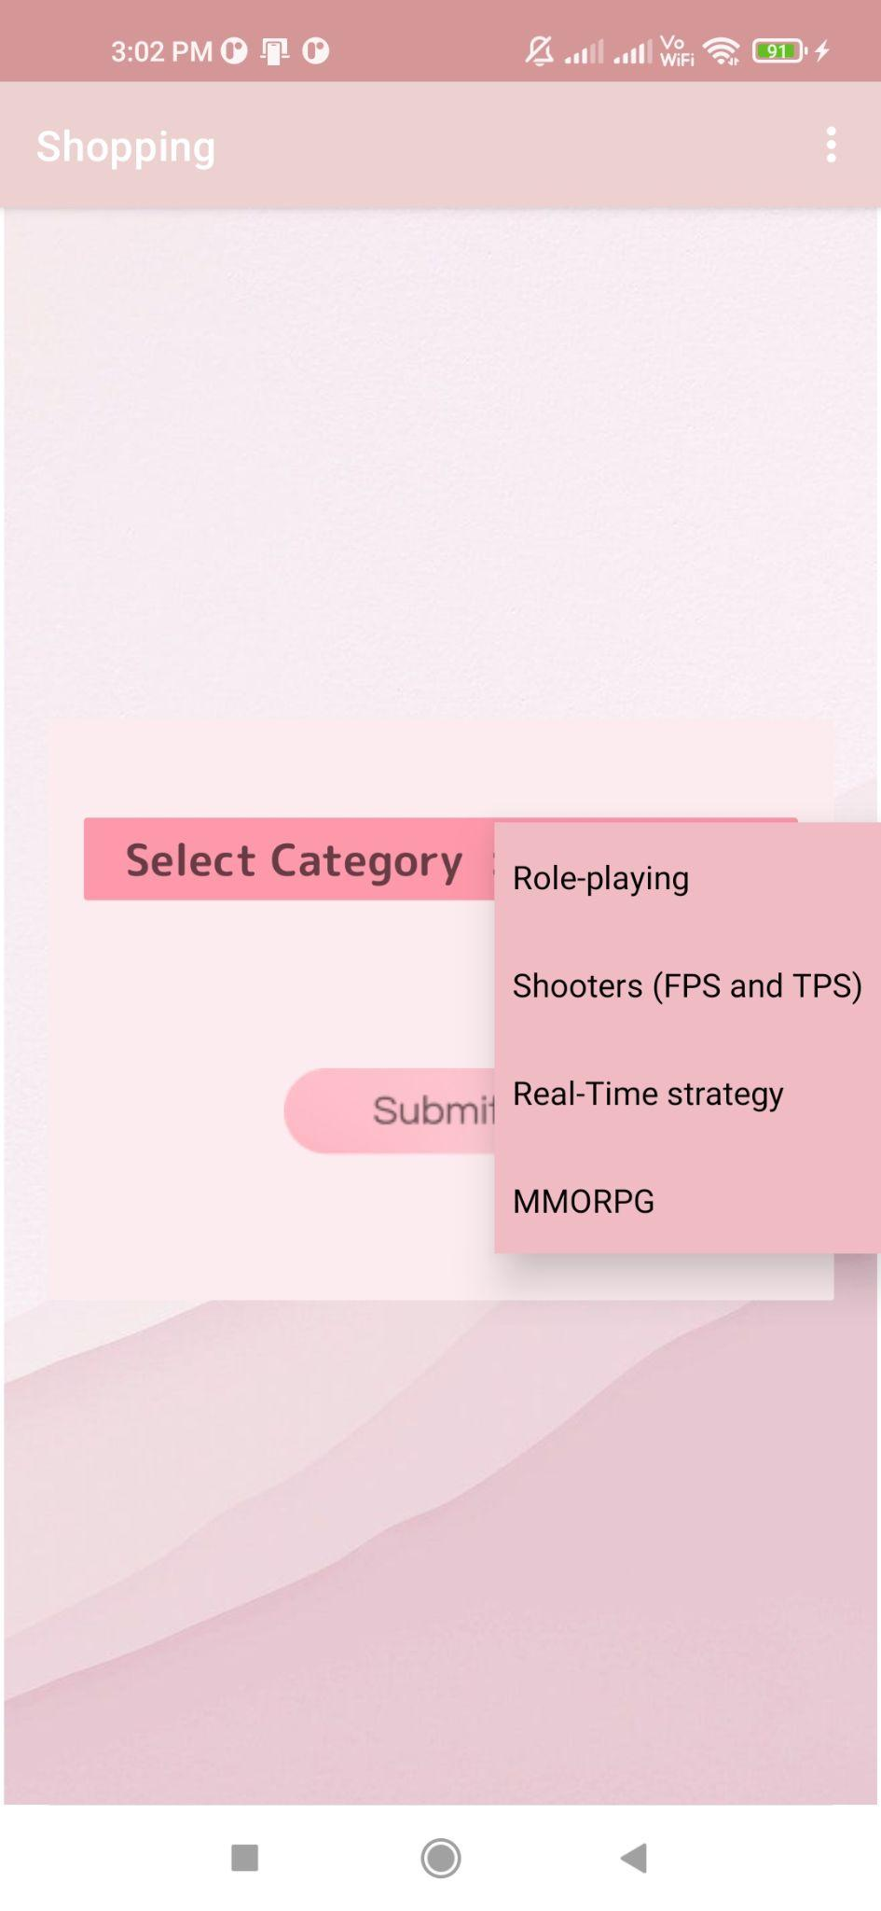

**Product.java**

**package com.example.shopping;**

**import androidx.annotation.NonNull;**

**import androidx.appcompat.app.AppCompatActivity;**

**import android.content.Context;**

**import android.content.Intent;**

**import android.database.sqlite.SQLiteDatabase;**

**import android.os.Bundle;**

**import android.view.Menu;**

**import android.view.MenuItem;**

**import android.view.View;**

**import android.widget.CheckBox;**

**import android.widget.ImageButton;**

**import android.widget.TextView;**

**import android.widget.Toast;**

**public class qnty extends AppCompatActivity {**

**CheckBox item1, item2, item3, item4;**

**TextView p1, p2, p3, p4;**

**ImageButton button;**

**SQLiteDatabase db;**

**@Override**

**protected void onCreate(Bundle savedInstanceState) {**

**super.onCreate(savedInstanceState);**

**setContentView(R.layout.activity_qnty);**

**item1 = findViewById(R.id.item1);**

**item2 = findViewById(R.id.item2);**

**item3 = findViewById(R.id.item3);**

**item4 = findViewById(R.id.item4);**

**p1 = findViewById(R.id.p1);**

**p2 = findViewById(R.id.p2);**

**p3 = findViewById(R.id.p3);**

**p4 = findViewById(R.id.p4);**

**button = findViewById(R.id.button);**

**String s="0";**

**db = openOrCreateDatabase("Shopping", Context.MODE_PRIVATE, null);**

**db.execSQL("Create table If not Exists ProductInfo(Name Varchar, Price Int)");**

**Bundle bundle = getIntent().getExtras();**

**try {**

**s = bundle.getString("list");**

**} catch (Exception e) {**

**s = "0";**

**Toast.makeText(getApplicationContext(), "Exception =" + e + "", Toast.LENGTH_SHORT).show();**

**}**

**switch (s) {**

**case "1":**

**String aItem1 = "Witcher 3";**

**int aP1 = 800;**

**String aItem2 = "Elden Ring";**

**int aP2 = 3999;**

**String aItem3 = "God of War";**

**int aP3 = 3299;**

**String aItem4 = "Dark souls";**

**int aP4 = 1199;**

**item1.setText(aItem1);**

**p1.setText("Rs." + aP1);**

**item2.setText(aItem2);**

**p2.setText("Rs." + aP2);**

**item3.setText(aItem3);**

**p3.setText("Rs." + aP3);**

**item4.setText(aItem4);**

**p4.setText("Rs." + aP4);**

**button.setOnClickListener(new View.OnClickListener() {**

**@Override**

**public void onClick(View view) {**

**if (item1.isChecked()) {**

**String A = "Insert into ProductInfo Values('" + aItem1 + "','" + aP1 + "')";**

**db.execSQL(A);**

**}**

**if (item2.isChecked()) {**

**String B = "Insert into ProductInfo Values('" + aItem2 + "','" + aP2 + "')";**

**db.execSQL(B);**

**}**

**if (item3.isChecked()) {**

**String C = "Insert into ProductInfo Values('" + aItem3 + "','" + aP3 + "')";**

**db.execSQL(C);**

**}**

**if (item4.isChecked()) {**

**String D = "Insert into ProductInfo Values('" + aItem4 + "','" + aP4 + "')";**

**db.execSQL(D);**

**}**

**Intent c = new Intent(getApplicationContext(), Cart.class);**

**startActivity(c);**

**}**

**});**

**break;**

**case "2":**

**String bItem1 = "Destiny";**

**int bP1 = 999;**

**String bItem2 = "COD";**

**int bP2 = 3999;**

**String bItem3 = "Battlefield 2042";**

**int bP3 = 2999;**

**String bItem4 = "Boom Eternal";**

**int bP4 = 3999;**

**item1.setText(bItem1);**

**p1.setText("Rs." + bP1);**

**item2.setText(bItem2);**

**p2.setText("Rs." + bP2);**

**item3.setText(bItem3);**

**p3.setText("Rs." + bP3);**

**item4.setText(bItem4);**

**p4.setText("Rs." + bP4);**

**button.setOnClickListener(new View.OnClickListener() {**

**@Override**

**public void onClick(View view) {**

**if (item1.isChecked()) {**

**String A = "Insert into ProductInfo Values('" + bItem1 + "','" + bP1 + "')";**

**db.execSQL(A);**

**}**

**if (item2.isChecked()) {**

**String B = "Insert into ProductInfo Values('" + bItem2 + "','" + bP2 + "')";**

**db.execSQL(B);**

**}**

**if (item3.isChecked()) {**

**String C = "Insert into ProductInfo Values('" + bItem3 + "','" + bP3 + "')";**

**db.execSQL(C);**

**}**

**if (item4.isChecked()) {**

**String D = "Insert into ProductInfo Values('" + bItem4 + "','" + bP4 + "')";**

**db.execSQL(D);**

**}**

**Intent c = new Intent(getApplicationContext(), Cart.class);**

**startActivity(c);**

**}**

**});**

**break;**

**case "3":**

**String cItem1 = "Warcraft 3";**

**int cP1 = 2100;**

**String cItem2 = "Starcarft 2 ";**

**int cP2 = 562;**

**String cItem3 = "Age of Empires 2";**

**int cP3 = 8109;**

**String cItem4 = "Rise of Nations";**

**int cP4 = 590;**

**item1.setText(cItem1);**

**p1.setText("Rs." + cP1);**

**item2.setText(cItem2);**

**p2.setText("Rs." + cP2);**

**item3.setText(cItem3);**

**p3.setText("Rs." + cP3);**

**item4.setText(cItem4);**

**p4.setText("Rs." + cP4);**

**button.setOnClickListener(new View.OnClickListener() {**

**@Override**

**public void onClick(View view) {**

**if (item1.isChecked()) {**

**String A = "Insert into ProductInfo Values('" + cItem1 + "','" + cP1 + "')";**

**db.execSQL(A);**

**}**

**if (item2.isChecked()) {**

**String B = "Insert into ProductInfo Values('" + cItem2 + "','" + cP2 + "')";**

**db.execSQL(B);**

**}**

**if (item3.isChecked()) {**

**String C = "Insert into ProductInfo Values('" + cItem3 + "','" + cP3 + "')";**

**db.execSQL(C);**

**}**

**if (item4.isChecked()) {**

**String D = "Insert into ProductInfo Values('" + cItem4 + "','" + cP4 + "')";**

**db.execSQL(D);**

**}**

**Intent c = new Intent(getApplicationContext(), Cart.class);**

**startActivity(c);**

**}**

**});**

**break;**

**case "4":**

**String dItem1 = "Final Fantasy 14";**

**int dP1 = 8316;**

**String dItem2 = "World of Warcraft";**

**int dP2 = 1290;**

**String dItem3 = "Guildwars 2";**

**int dP3 = 3999;**

**String dItem4 = "Neverwinter Nights";**

**int dP4 = 1290;**

**item1.setText(dItem1);**

**p1.setText("Rs." + dP1);**

**item2.setText(dItem2);**

**p2.setText("Rs." + dP2);**

**item3.setText(dItem3);**

**p3.setText("Rs." + dP3);**

**item4.setText(dItem4);**

**p4.setText("Rs." + dP4);**

**button.setOnClickListener(new View.OnClickListener() {**

**@Override**

**public void onClick(View view) {**

**if (item1.isChecked()) {**

**String A = "Insert into ProductInfo Values('" + dItem1 + "','" + dP1 + "')";**

**db.execSQL(A);**

**}**

**if (item2.isChecked()) {**

**String B = "Insert into ProductInfo Values('" + dItem2 + "','" + dP2 + "')";**

**db.execSQL(B);**

**}**

**if (item3.isChecked()) {**

**String C = "Insert into ProductInfo Values('" + dItem3 + "','" + dP3 + "')";**

**db.execSQL(C);**

**}**

**if (item4.isChecked()) {**

**String D = "Insert into ProductInfo Values('" + dItem4 + "','" + dP4 + "')";**

**db.execSQL(D);**

**}**

**Intent c = new Intent(getApplicationContext(), Cart.class);**

**startActivity(c);**

**}**

**});**

**break;**

**}**

**}**

**@Override**

**public boolean onCreateOptionsMenu(Menu menu) {**

**getMenuInflater().inflate(R.menu.menu, menu);**

**return true;**

**}**

**@Override**

**public boolean onOptionsItemSelected(@NonNull MenuItem item) {**

**int id = item.getItemId();**

**if (id == R.id.cart) {**

**Intent s = new Intent(getApplicationContext(), Cart.class);**

**startActivity(s);**

**}**

**if (id == R.id.bill) {**

**Intent u = new Intent(getApplicationContext(), Bill.class);**

**startActivity(u);**

**}**

**if (id == R.id.product) {**

**Intent d = new Intent(getApplicationContext(), Category.class);**

**startActivity(d);**

**}**

**return super.onOptionsItemSelected(item);**

**}**

**}**

**Product.xml**

**<?xml version="1.0" encoding="utf-8"?>**

**<androidx.constraintlayout.widget.ConstraintLayout xmlns:android="http://schemas.android.com/apk/res/android"**

**xmlns:app="http://schemas.android.com/apk/res-auto"**

**xmlns:tools="http://schemas.android.com/tools"**

**android:layout_width="match_parent"**

**android:layout_height="match_parent"**

**android:backgroundTint="#00FFFFFF"**

**tools:context=".qnty">**

**<ImageView**

**android:id="@+id/imageView5"**

**android:layout_width="wrap_content"**

**android:layout_height="wrap_content"**

**app:srcCompat="@drawable/qnty"**

**tools:layout_editor_absoluteX="0dp"**

**tools:layout_editor_absoluteY="0dp" />**

**<CheckBox**

**android:id="@+id/item1"**

**android:layout_width="wrap_content"**

**android:layout_height="wrap_content"**

**android:buttonTint="@color/your_color"**

**app:layout_constraintBottom_toBottomOf="parent"**

**app:layout_constraintEnd_toEndOf="parent"**

**app:layout_constraintHorizontal_bias="0.247"**

**app:layout_constraintStart_toStartOf="parent"**

**app:layout_constraintTop_toTopOf="parent"**

**app:layout_constraintVertical_bias="0.338" />**

**<CheckBox**

**android:id="@+id/item4"**

**android:layout_width="wrap_content"**

**android:layout_height="wrap_content"**

**android:buttonTint="@color/your_color"**

**app:layout_constraintBottom_toBottomOf="parent"**

**app:layout_constraintEnd_toEndOf="parent"**

**app:layout_constraintHorizontal_bias="0.247"**

**app:layout_constraintStart_toStartOf="parent"**

**app:layout_constraintTop_toTopOf="parent"**

**app:layout_constraintVertical_bias="0.633" />**

**<CheckBox**

**android:id="@+id/item3"**

**android:layout_width="wrap_content"**

**android:layout_height="wrap_content"**

**android:buttonTint="@color/your_color"**

**app:layout_constraintBottom_toBottomOf="parent"**

**app:layout_constraintEnd_toEndOf="parent"**

**app:layout_constraintHorizontal_bias="0.247"**

**app:layout_constraintStart_toStartOf="parent"**

**app:layout_constraintTop_toTopOf="parent"**

**app:layout_constraintVertical_bias="0.541" />**

**<CheckBox**

**android:id="@+id/item2"**

**android:layout_width="wrap_content"**

**android:layout_height="wrap_content"**

**android:buttonTint="@color/your_color"**

**app:layout_constraintBottom_toBottomOf="parent"**

**app:layout_constraintEnd_toEndOf="parent"**

**app:layout_constraintHorizontal_bias="0.247"**

**app:layout_constraintStart_toStartOf="parent"**

**app:layout_constraintTop_toTopOf="parent"**

**app:layout_constraintVertical_bias="0.434" />**

**<TextView**

**android:id="@+id/p1"**

**android:layout_width="98dp"**

**android:layout_height="48dp"**

**android:ems="10"**

**android:inputType="number"**

**app:layout_constraintBottom_toBottomOf="parent"**

**app:layout_constraintEnd_toEndOf="parent"**

**app:layout_constraintHorizontal_bias="0.766"**

**app:layout_constraintStart_toStartOf="parent"**

**app:layout_constraintTop_toTopOf="parent"**

**app:layout_constraintVertical_bias="0.364" />**

**<TextView**

**android:id="@+id/p2"**

**android:layout_width="98dp"**

**android:layout_height="48dp"**

**android:ems="10"**

**android:inputType="number"**

**app:layout_constraintBottom_toBottomOf="parent"**

**app:layout_constraintEnd_toEndOf="parent"**

**app:layout_constraintHorizontal_bias="0.766"**

**app:layout_constraintStart_toStartOf="parent"**

**app:layout_constraintTop_toTopOf="parent"**

**app:layout_constraintVertical_bias="0.461" />**

**<TextView**

**android:id="@+id/p3"**

**android:layout_width="98dp"**

**android:layout_height="48dp"**

**android:ems="10"**

**android:inputType="number"**

**app:layout_constraintBottom_toBottomOf="parent"**

**app:layout_constraintEnd_toEndOf="parent"**

**app:layout_constraintHorizontal_bias="0.766"**

**app:layout_constraintStart_toStartOf="parent"**

**app:layout_constraintTop_toTopOf="parent"**

**app:layout_constraintVertical_bias="0.563" />**

**<TextView**

**android:id="@+id/p4"**

**android:layout_width="98dp"**

**android:layout_height="48dp"**

**android:ems="10"**

**android:inputType="number"**

**app:layout_constraintBottom_toBottomOf="parent"**

**app:layout_constraintEnd_toEndOf="parent"**

**app:layout_constraintHorizontal_bias="0.766"**

**app:layout_constraintStart_toStartOf="parent"**

**app:layout_constraintTop_toTopOf="parent"**

**app:layout_constraintVertical_bias="0.667" />**

**<ImageButton**

**android:id="@+id/button"**

**android:layout_width="wrap_content"**

**android:layout_height="wrap_content"**

**android:backgroundTint="#00FFFFFF"**

**app:layout_constraintBottom_toBottomOf="@+id/imageView5"**

**app:layout_constraintEnd_toEndOf="parent"**

**app:layout_constraintHorizontal_bias="0.497"**

**app:layout_constraintStart_toStartOf="parent"**

**app:layout_constraintTop_toTopOf="parent"**

**app:layout_constraintVertical_bias="0.76"**

**app:srcCompat="@drawable/submit" />**

**</androidx.constraintlayout.widget.ConstraintLayout>**

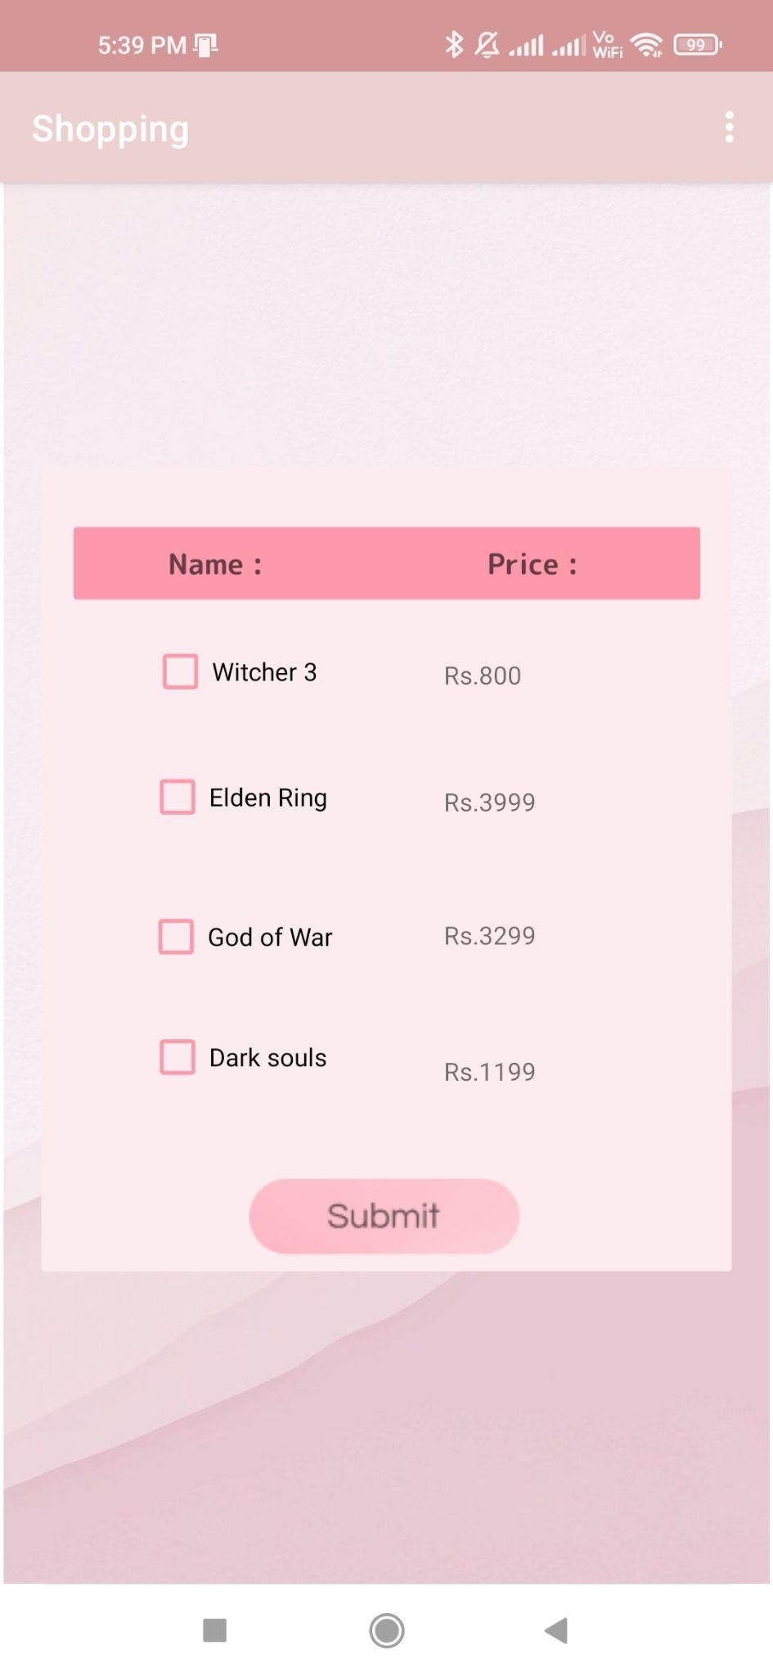

**Cart.java**

**package com.example.shopping;**

**import androidx.annotation.NonNull;**

**import androidx.appcompat.app.AppCompatActivity;**

**import android.content.Context;**

**import android.content.Intent;**

**import android.database.Cursor;**

**import android.database.sqlite.SQLiteDatabase;**

**import android.os.Bundle;**

**import android.text.Editable;**

**import android.text.TextWatcher;**

**import android.view.Menu;**

**import android.view.MenuItem;**

**import android.view.View;**

**import android.widget.EditText;**

**import android.widget.ImageButton;**

**import android.widget.TextView;**

**import android.widget.Toast;**

**public class Cart extends AppCompatActivity {**

**TextView p1, p2, p3, p4, game1, game2, game3, game4, total1, total2, total3, total4, gtotal;**

**EditText q1, q2, q3, q4;**

**ImageButton button;**

**String pp1;**

**String pp2;**

**String pp3;**

**String pp4;**

**SQLiteDatabase db;**

**@Override**

**protected void onCreate(Bundle savedInstanceState) {**

**super.onCreate(savedInstanceState);**

**setContentView(R.layout.activity_cart);**

**p1 = findViewById(R.id.bprice1);**

**p2 = findViewById(R.id.bprice2);**

**p3 = findViewById(R.id.bprice3);**

**p4 = findViewById(R.id.price4);**

**q1 = findViewById(R.id.bqnty1);**

**q2 = findViewById(R.id.bqnty2);**

**q3 = findViewById(R.id.bqnty3);**

**q4 = findViewById(R.id.cqnty4);**

**game1 = findViewById(R.id.bgame1);**

**game2 = findViewById(R.id.bgame2);**

**game3 = findViewById(R.id.bgame3);**

**game4 = findViewById(R.id.bgame4);**

**total1 = findViewById(R.id.ctotal1);**

**total2 = findViewById(R.id.ctotal2);**

**total3 = findViewById(R.id.ctotal3);**

**total4 = findViewById(R.id.ctotal4);**

**gtotal = findViewById(R.id.gtotal);**

**button = findViewById(R.id.cbutton);**

**q1.setVisibility(View.INVISIBLE);**

**q2.setVisibility(View.INVISIBLE);**

**q3.setVisibility(View.INVISIBLE);**

**q4.setVisibility(View.INVISIBLE);**

**db = openOrCreateDatabase("Shopping", Context.MODE_PRIVATE, null);**

**db.execSQL("Create table If not Exists ProductInfo(Name Varchar, Price Int)");**

**db.execSQL("Create table If not Exists PriceInfo(qnty Varchar, subprice Varchar)");**

**String query = "select * from ProductInfo";**

**Cursor sql = db.rawQuery(query, null);**

**try {**

**sql.moveToFirst();**

**game1.setText(sql.getString(0));**

**p1.setText(sql.getString(1));**

**pp1 = sql.getString(1);**

**total1.setText(pp1);**

**sql.moveToNext();**

**game2.setText(sql.getString(0));**

**p2.setText( sql.getString(1));**

**pp2 = sql.getString(1);**

**total2.setText(pp2);**

**sql.moveToNext();**

**game3.setText(sql.getString(0));**

**p3.setText(sql.getString(1));**

**pp3 = sql.getString(1);**

**total3.setText(pp3);**

**sql.moveToNext();**

**game4.setText(sql.getString(0));**

**p4.setText(sql.getString(1));**

**pp4 = sql.getString(1);**

**total4.setText(pp4);**

**}**

**catch (Exception e){**

**}**

**if (!(game1.getText().toString().isEmpty())) {**

**q1.setVisibility(View.VISIBLE);**

**}**

**if (!(game2.getText().toString().isEmpty())) {**

**q2.setVisibility(View.VISIBLE);**

**}**

**if (!(game3.getText().toString().isEmpty())) {**

**q3.setVisibility(View.VISIBLE);**

**}**

**if (!(game4.getText().toString().isEmpty())) {**

**q4.setVisibility(View.VISIBLE);**

**}**

**int possiblet1 = 0;**

**int possiblet2 = 0;**

**int possiblet3 = 0;**

**int possiblet4 = 0;**

**try {**

**possiblet1 = Integer.parseInt(total1.getText().toString());**

**possiblet2 = Integer.parseInt(total2.getText().toString());**

**possiblet3 = Integer.parseInt(total3.getText().toString());**

**possiblet4 = Integer.parseInt(total4.getText().toString());**

**int T = possiblet1 + possiblet2 + possiblet3 + possiblet4;**

**gtotal.setText(""+T+"");**

**}**

**catch (Exception whTy){**

**int T = possiblet1 + possiblet2 + possiblet3 + possiblet4;**

**gtotal.setText(""+T+"");**

**}**

**q1.addTextChangedListener(new TextWatcher() {**

**@Override**

**public void beforeTextChanged(CharSequence charSequence, int i, int i1, int i2) {**

**}**

**@Override**

**public void onTextChanged(CharSequence charSequence, int i, int i1, int i2) {**

**}**

**@Override**

**public void afterTextChanged(Editable editable) {**

**int Q1 = 0;**

**try {**

**if (editable == null) {**

**Q1 = 0;**

**} else {**

**Q1 = Integer.parseInt(editable.toString());**

**}**

**} catch (Exception WHyt) {**

**Toast.makeText(getApplicationContext(), "Add a Digit", Toast.LENGTH_SHORT).show();**

**}**

**int P1 = Integer.parseInt(pp1);**

**int tempTotal = Q1 * P1;**

**total1.setText("" + tempTotal + "");**

**int possible1 = 0;**

**int possible2 = 0;**

**int possible3 = 0;**

**int possible4 = 0;**

**try {**

**possible1 = Integer.parseInt(total1.getText().toString());**

**possible2 = Integer.parseInt(total2.getText().toString());**

**possible3 = Integer.parseInt(total3.getText().toString());**

**possible4 = Integer.parseInt(total4.getText().toString());**

**int T = possible1 + possible2 + possible3 + possible4;**

**gtotal.setText(""+T+"");**

**}**

**catch (Exception whTy){**

**// Toast.makeText(getApplicationContext(),whTy.toString() ,Toast.LENGTH_SHORT).show();**

**}**

**}**

**});**

**q2.addTextChangedListener(new TextWatcher() {**

**@Override**

**public void beforeTextChanged(CharSequence charSequence, int i, int i1, int i2) {**

**}**

**@Override**

**public void onTextChanged(CharSequence charSequence, int i, int i1, int i2) {**

**}**

**@Override**

**public void afterTextChanged(Editable editable) {**

**int Q2 = 0;**

**try {**

**if(editable == null) {**

**Q2 = 0;**

**}**

**else {**

**Q2 = Integer.parseInt(editable.toString());**

**}**

**}**

**catch (Exception WHyt) {**

**Toast.makeText(getApplicationContext(), "Add a Digit", Toast.LENGTH_SHORT).show();**

**}**

**int P2 = Integer.parseInt(pp2);**

**int tempTotal = Q2 * P2;**

**total2.setText("" + tempTotal + "");**

**int possible1 = 0;**

**int possible2 = 0;**

**int possible3 = 0;**

**int possible4 = 0;**

**try {**

**possible1 = Integer.parseInt(total1.getText().toString());**

**possible2 = Integer.parseInt(total2.getText().toString());**

**possible3 = Integer.parseInt(total3.getText().toString());**

**possible4 = Integer.parseInt(total4.getText().toString());**

**int T = possible1 + possible2 + possible3 + possible4;**

**gtotal.setText(""+T+"");**

**}**

**catch (Exception whTy){**

**int T = possible1 + possible2 + possible3 + possible4;**

**gtotal.setText(""+T+"");**

**}**

**}**

**});**

**q3.addTextChangedListener(new TextWatcher() {**

**@Override**

**public void beforeTextChanged(CharSequence charSequence, int i, int i1, int i2) {**

**}**

**@Override**

**public void onTextChanged(CharSequence charSequence, int i, int i1, int i2) {**

**}**

**@Override**

**public void afterTextChanged(Editable editable) {**

**int Q3 = 0;**

**try {**

**if(editable == null) {**

**Q3 = 0;**

**}**

**else {**

**Q3 = Integer.parseInt(editable.toString());**

**}**

**}**

**catch (Exception WHyt) {**

**Toast.makeText(getApplicationContext(), "Add a Digit", Toast.LENGTH_SHORT).show();**

**}**

**int P3 = Integer.parseInt(pp3);**

**int tempTotal1 = Q3 * P3;**

**total3.setText("" + tempTotal1 + "");**

**int possible1 = 0;**

**int possible2 = 0;**

**int possible3 = 0;**

**int possible4 = 0;**

**try {**

**possible1 = Integer.parseInt(total1.getText().toString());**

**possible2 = Integer.parseInt(total2.getText().toString());**

**possible3 = Integer.parseInt(total3.getText().toString());**

**possible4 = Integer.parseInt(total4.getText().toString());**

**int T = possible1 + possible2 + possible3 + possible4;**

**gtotal.setText(""+T+"");**

**}**

**catch (Exception whTy){**

**int T = possible1 + possible2 + possible3 + possible4;**

**gtotal.setText(""+T+"");**

**}**

**}**

**});**

**q4.addTextChangedListener(new TextWatcher() {**

**@Override**

**public void beforeTextChanged(CharSequence charSequence, int i, int i1, int i2) {**

**}**

**@Override**

**public void onTextChanged(CharSequence charSequence, int i, int i1, int i2) {**

**}**

**@Override**

**public void afterTextChanged(Editable editable) {**

**int Q4 = 0;**

**try {**

**if(editable == null) {**

**Q4= 0;**

**}**

**else {**

**Q4 = Integer.parseInt(editable.toString());**

**}**

**}**

**catch (Exception WHyt) {**

**Toast.makeText(getApplicationContext(), "Add a Digit", Toast.LENGTH_SHORT).show();**

**}**

**int P4 = Integer.parseInt(pp4);**

**int tempTotal2 = Q4 * P4;**

**total4.setText("" + tempTotal2 + "");**

**gtotal.setText(""+ tempTotal2 + "");**

**int possible1 = 0;**

**int possible2 = 0;**

**int possible3 = 0;**

**int possible4 = 0;**

**try {**

**possible1 = Integer.parseInt(total1.getText().toString());**

**possible2 = Integer.parseInt(total2.getText().toString());**

**possible3 = Integer.parseInt(total3.getText().toString());**

**possible4 = Integer.parseInt(total4.getText().toString());**

**int T = possible1 + possible2 + possible3 + possible4;**

**gtotal.setText(""+T+"");**

**}**

**catch (Exception whTy){**

**int T = possible1 + possible2 + possible3 + possible4;**

**gtotal.setText(""+T+"");**

**}**

**}**

**});**

**button.setOnClickListener(new View.OnClickListener() {**

**@Override**

**public void onClick(View view) {**

**String A = "Insert into PriceInfo Values('" + q1.getText().toString() + "','" + total1.getText().toString() + "')";**

**db.execSQL(A);**

**String B = "Insert into PriceInfo Values('" + q2.getText().toString() + "','" + total2.getText().toString() + "')";**

**db.execSQL(B);**

**String C = "Insert into PriceInfo Values('" + q3.getText().toString() + "','" + total3.getText().toString() + "')";**

**db.execSQL(C);**

**String D = "Insert into PriceInfo Values('" + q4.getText().toString() + "','" + total4.getText().toString() + "')";**

**db.execSQL(D);**

**Intent i = new Intent(getApplicationContext(), Bill.class);**

**startActivity(i);**

**}**

**});**

**}**

**@Override**

**public boolean onCreateOptionsMenu(Menu menu) {**

**getMenuInflater().inflate(R.menu.menu, menu);**

**return true;**

**}**

**@Override**

**public boolean onOptionsItemSelected(@NonNull MenuItem item) {**

**int id = item.getItemId();**

**if (id == R.id.cart) {**

**Intent s = new Intent(getApplicationContext(), Cart.class);**

**startActivity(s);**

**}**

**if (id == R.id.bill) {**

**Intent u = new Intent(getApplicationContext(), Bill.class);**

**startActivity(u);**

**}**

**if (id == R.id.product) {**

**Intent d = new Intent(getApplicationContext(), Category.class);**

**startActivity(d);**

**}**

**return super.onOptionsItemSelected(item);**

**}**

**}**

**Cart.xml**

**<?xml version="1.0" encoding="utf-8"?>**

**<androidx.constraintlayout.widget.ConstraintLayout xmlns:android="http://schemas.android.com/apk/res/android"**

**xmlns:app="http://schemas.android.com/apk/res-auto"**

**xmlns:tools="http://schemas.android.com/tools"**

**android:layout_width="match_parent"**

**android:layout_height="match_parent"**

**tools:context=".Cart">**

**<ImageView**

**android:id="@+id/imageView6"**

**android:layout_width="wrap_content"**

**android:layout_height="wrap_content"**

**app:srcCompat="@drawable/cartt"**

**tools:layout_editor_absoluteX="0dp"**

**tools:layout_editor_absoluteY="0dp" />**

**<TextView**

**android:id="@+id/bgame1"**

**android:layout_width="wrap_content"**

**android:layout_height="wrap_content"**

**android:textStyle="italic"**

**app:layout_constraintBottom_toBottomOf="parent"**

**app:layout_constraintEnd_toEndOf="parent"**

**app:layout_constraintHorizontal_bias="0.127"**

**app:layout_constraintStart_toStartOf="parent"**

**app:layout_constraintTop_toTopOf="parent"**

**app:layout_constraintVertical_bias="0.39" />**

**<TextView**

**android:id="@+id/bprice1"**

**android:layout_width="wrap_content"**

**android:layout_height="wrap_content"**

**android:textStyle="normal"**

**app:layout_constraintBottom_toBottomOf="parent"**

**app:layout_constraintEnd_toEndOf="parent"**

**app:layout_constraintHorizontal_bias="0.423"**

**app:layout_constraintStart_toStartOf="parent"**

**app:layout_constraintTop_toTopOf="parent"**

**app:layout_constraintVertical_bias="0.39" />**

**<TextView**

**android:id="@+id/bprice3"**

**android:layout_width="wrap_content"**

**android:layout_height="wrap_content"**

**android:textStyle="normal"**

**app:layout_constraintBottom_toBottomOf="parent"**

**app:layout_constraintEnd_toEndOf="parent"**

**app:layout_constraintHorizontal_bias="0.423"**

**app:layout_constraintStart_toStartOf="parent"**

**app:layout_constraintTop_toTopOf="parent"**

**app:layout_constraintVertical_bias="0.59000003" />**

**<TextView**

**android:id="@+id/price4"**

**android:layout_width="wrap_content"**

**android:layout_height="wrap_content"**

**android:textStyle="normal"**

**app:layout_constraintBottom_toBottomOf="parent"**

**app:layout_constraintEnd_toEndOf="parent"**

**app:layout_constraintHorizontal_bias="0.423"**

**app:layout_constraintStart_toStartOf="parent"**

**app:layout_constraintTop_toTopOf="parent"**

**app:layout_constraintVertical_bias="0.69" />**

**<TextView**

**android:id="@+id/bprice2"**

**android:layout_width="wrap_content"**

**android:layout_height="wrap_content"**

**android:textStyle="normal"**

**app:layout_constraintBottom_toBottomOf="parent"**

**app:layout_constraintEnd_toEndOf="parent"**

**app:layout_constraintHorizontal_bias="0.423"**

**app:layout_constraintStart_toStartOf="parent"**

**app:layout_constraintTop_toTopOf="parent"**

**app:layout_constraintVertical_bias="0.49" />**

**<EditText**

**android:id="@+id/bqnty1"**

**android:layout_width="wrap_content"**

**android:layout_height="wrap_content"**

**android:inputType="number"**

**android:text="1"**

**app:layout_constraintBottom_toBottomOf="parent"**

**app:layout_constraintEnd_toEndOf="parent"**

**app:layout_constraintHorizontal_bias="0.609"**

**app:layout_constraintStart_toStartOf="parent"**

**app:layout_constraintTop_toTopOf="parent"**

**app:layout_constraintVertical_bias="0.39" />**

**<TextView**

**android:id="@+id/ctotal1"**

**android:layout_width="wrap_content"**

**android:layout_height="wrap_content"**

**android:textStyle="bold"**

**app:layout_constraintBottom_toBottomOf="parent"**

**app:layout_constraintEnd_toEndOf="parent"**

**app:layout_constraintHorizontal_bias="0.847"**

**app:layout_constraintStart_toStartOf="parent"**

**app:layout_constraintTop_toTopOf="parent"**

**app:layout_constraintVertical_bias="0.39" />**

**<TextView**

**android:id="@+id/ctotal2"**

**android:layout_width="wrap_content"**

**android:layout_height="wrap_content"**

**android:textStyle="bold"**

**app:layout_constraintBottom_toBottomOf="parent"**

**app:layout_constraintEnd_toEndOf="parent"**

**app:layout_constraintHorizontal_bias="0.847"**

**app:layout_constraintStart_toStartOf="parent"**

**app:layout_constraintTop_toTopOf="parent"**

**app:layout_constraintVertical_bias="0.49" />**

**<TextView**

**android:id="@+id/bgame2"**

**android:layout_width="wrap_content"**

**android:layout_height="wrap_content"**

**android:textStyle="italic"**

**app:layout_constraintBottom_toBottomOf="parent"**

**app:layout_constraintEnd_toEndOf="parent"**

**app:layout_constraintHorizontal_bias="0.126"**

**app:layout_constraintStart_toStartOf="parent"**

**app:layout_constraintTop_toTopOf="parent"**

**app:layout_constraintVertical_bias="0.49" />**

**<TextView**

**android:id="@+id/bgame3"**

**android:layout_width="wrap_content"**

**android:layout_height="wrap_content"**

**android:textStyle="italic"**

**app:layout_constraintBottom_toBottomOf="parent"**

**app:layout_constraintEnd_toEndOf="parent"**

**app:layout_constraintHorizontal_bias="0.126"**

**app:layout_constraintStart_toStartOf="parent"**

**app:layout_constraintTop_toTopOf="parent"**

**app:layout_constraintVertical_bias="0.59000003" />**

**<EditText**

**android:id="@+id/bqnty3"**

**android:layout_width="wrap_content"**

**android:layout_height="wrap_content"**

**android:inputType="number"**

**android:text="1"**

**app:layout_constraintBottom_toBottomOf="parent"**

**app:layout_constraintEnd_toEndOf="parent"**

**app:layout_constraintHorizontal_bias="0.609"**

**app:layout_constraintStart_toStartOf="parent"**

**app:layout_constraintTop_toTopOf="parent"**

**app:layout_constraintVertical_bias="0.59000003" />**

**<TextView**

**android:id="@+id/ctotal3"**

**android:layout_width="wrap_content"**

**android:layout_height="wrap_content"**

**android:textStyle="bold"**

**app:layout_constraintBottom_toBottomOf="parent"**

**app:layout_constraintEnd_toEndOf="parent"**

**app:layout_constraintHorizontal_bias="0.847"**

**app:layout_constraintStart_toStartOf="parent"**

**app:layout_constraintTop_toTopOf="parent"**

**app:layout_constraintVertical_bias="0.59000003" />**

**<TextView**

**android:id="@+id/ctotal4"**

**android:layout_width="wrap_content"**

**android:layout_height="wrap_content"**

**android:textStyle="bold"**

**app:layout_constraintBottom_toBottomOf="parent"**

**app:layout_constraintEnd_toEndOf="parent"**

**app:layout_constraintHorizontal_bias="0.847"**

**app:layout_constraintStart_toStartOf="parent"**

**app:layout_constraintTop_toTopOf="parent"**

**app:layout_constraintVertical_bias="0.69" />**

**<TextView**

**android:id="@+id/gtotal"**

**android:layout_width="wrap_content"**

**android:layout_height="wrap_content"**

**android:inputType="number"**

**android:text="0"**

**android:textSize="16sp"**

**android:textStyle="bold"**

**app:layout_constraintBottom_toBottomOf="parent"**

**app:layout_constraintEnd_toEndOf="parent"**

**app:layout_constraintHorizontal_bias="0.845"**

**app:layout_constraintStart_toStartOf="parent"**

**app:layout_constraintTop_toTopOf="parent"**

**app:layout_constraintVertical_bias="0.823" />**

**<EditText**

**android:id="@+id/cqnty4"**

**android:layout_width="wrap_content"**

**android:layout_height="wrap_content"**

**android:inputType="number"**

**android:text="1"**

**app:layout_constraintBottom_toBottomOf="parent"**

**app:layout_constraintEnd_toEndOf="parent"**

**app:layout_constraintHorizontal_bias="0.608"**

**app:layout_constraintStart_toStartOf="parent"**

**app:layout_constraintTop_toTopOf="parent"**

**app:layout_constraintVertical_bias="0.69" />**

**<TextView**

**android:id="@+id/bgame4"**

**android:layout_width="wrap_content"**

**android:layout_height="wrap_content"**

**android:textStyle="italic"**

**app:layout_constraintBottom_toBottomOf="parent"**

**app:layout_constraintEnd_toEndOf="parent"**

**app:layout_constraintHorizontal_bias="0.126"**

**app:layout_constraintStart_toStartOf="parent"**

**app:layout_constraintTop_toTopOf="parent"**

**app:layout_constraintVertical_bias="0.69" />**

**<EditText**

**android:id="@+id/bqnty2"**

**android:layout_width="wrap_content"**

**android:layout_height="wrap_content"**

**android:inputType="number"**

**android:text="1"**

**app:layout_constraintBottom_toBottomOf="parent"**

**app:layout_constraintEnd_toEndOf="parent"**

**app:layout_constraintHorizontal_bias="0.609"**

**app:layout_constraintStart_toStartOf="parent"**

**app:layout_constraintTop_toTopOf="parent"**

**app:layout_constraintVertical_bias="0.49" />**

**<ImageButton**

**android:id="@+id/cbutton"**

**android:layout_width="wrap_content"**

**android:layout_height="wrap_content"**

**android:backgroundTint="#00FFFFFF"**

**app:layout_constraintBottom_toBottomOf="parent"**

**app:layout_constraintEnd_toEndOf="parent"**

**app:layout_constraintHorizontal_bias="0.208"**

**app:layout_constraintStart_toStartOf="parent"**

**app:layout_constraintTop_toTopOf="parent"**

**app:layout_constraintVertical_bias="0.841"**

**app:srcCompat="@drawable/submit" />**

**</androidx.constraintlayout.widget.ConstraintLayout>**

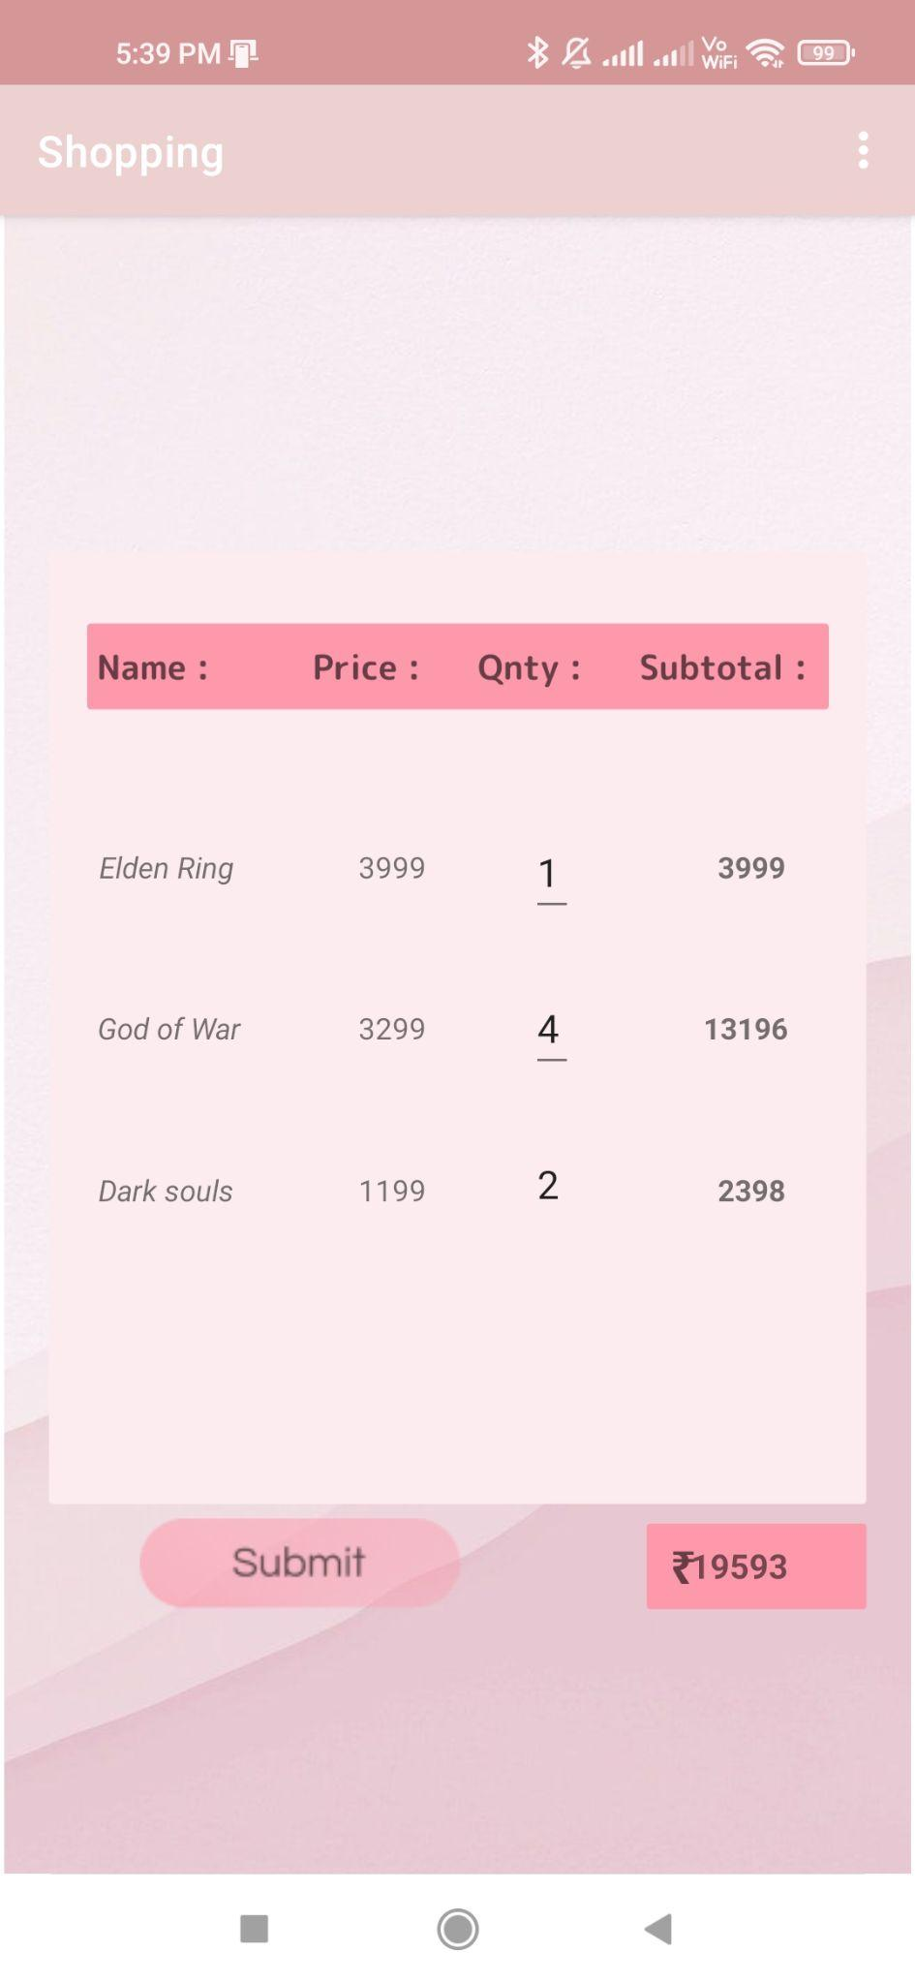

**Bill.java**

**package com.example.shopping;**

**import androidx.annotation.NonNull;**

**import androidx.appcompat.app.AppCompatActivity;**

**import android.content.Context;**

**import android.content.Intent;**

**import android.database.Cursor;**

**import android.database.sqlite.SQLiteDatabase;**

**import android.os.Bundle;**

**import android.view.Menu;**

**import android.view.MenuItem;**

**import android.view.View;**

**import android.widget.TextView;**

**public class Bill extends AppCompatActivity {**

**SQLiteDatabase db;**

**TextView p1, p2, p3, p4, game1, game2, game3, game4, total1, total2, total3, total4, total, q1, q2, q3, q4;**

**@Override**

**protected void onCreate(Bundle savedInstanceState) {**

**super.onCreate(savedInstanceState);**

**setContentView(R.layout.activity_bill);**

**game1 = findViewById(R.id.bgame1);**

**game2 = findViewById(R.id.bgame2);**

**game3 = findViewById(R.id.bgame3);**

**game4 = findViewById(R.id.bgame4);**

**p1 = findViewById(R.id.bprice1);**

**p2 = findViewById(R.id.bprice2);**

**p3 = findViewById(R.id.bprice3);**

**p4 = findViewById(R.id.bprice4);**

**total = findViewById(R.id.btotal);**

**total1 = findViewById(R.id.btotal1);**

**total2 = findViewById(R.id.btotal2);**

**total3 = findViewById(R.id.btotal3);**

**total4 = findViewById(R.id.btotal4);**

**q1 = findViewById(R.id.bqnty1);**

**q2 = findViewById(R.id.bqnty2);**

**q3 = findViewById(R.id.bqnty3);**

**q4 = findViewById(R.id.bqnty4);**

**q1.setVisibility(View.INVISIBLE);**

**q2.setVisibility(View.INVISIBLE);**

**q3.setVisibility(View.INVISIBLE);**

**q4.setVisibility(View.INVISIBLE);**

**db = openOrCreateDatabase("Shopping", Context.MODE_PRIVATE, null);**

**db.execSQL("Create table If not Exists ProductInfo(Name Varchar, Price Int)");**

**db.execSQL("Create table If not Exists PriceInfo(qnty Varchar, subprice Int)");**

**String query = "select * from ProductInfo";**

**Cursor sql = db.rawQuery(query, null);**

**try {**

**sql.moveToFirst();**

**game1.setText(sql.getString(0));**

**p1.setText(sql.getString(1));**

**sql.moveToNext();**

**game2.setText(sql.getString(0));**

**p2.setText( sql.getString(1));**

**sql.moveToNext();**

**game3.setText(sql.getString(0));**

**p3.setText(sql.getString(1));**

**sql.moveToNext();**

**game4.setText(sql.getString(0));**

**p4.setText(sql.getString(1));**

**}**

**catch (Exception e){**

**}**

**String query1 = "select * from PriceInfo";**

**Cursor Sql = db.rawQuery(query1, null);**

**try {**

**Sql.moveToFirst();**

**q1.setText(Sql.getString(0));**

**total1.setText(Sql.getString(1));**

**Sql.moveToNext();**

**q2.setText(Sql.getString(0));**

**total2.setText( Sql.getString(1));**

**Sql.moveToNext();**

**q3.setText(Sql.getString(0));**

**total3.setText(Sql.getString(1));**

**Sql.moveToNext();**

**q4.setText(Sql.getString(0));**

**total4.setText(Sql.getString(1));**

**}**

**catch (Exception e){**

**}**

**if (!(game1.getText().toString().isEmpty())) {**

**q1.setVisibility(View.VISIBLE);**

**}**

**if (!(game2.getText().toString().isEmpty())) {**

**q2.setVisibility(View.VISIBLE);**

**}**

**if (!(game3.getText().toString().isEmpty())) {**

**q3.setVisibility(View.VISIBLE);**

**}**

**if (!(game4.getText().toString().isEmpty())) {**

**q4.setVisibility(View.VISIBLE);**

**}**

**int possible1 = 0;**

**int possible2 = 0;**

**int possible3 = 0;**

**int possible4 = 0;**

**try {**

**possible1 = Integer.parseInt(total1.getText().toString());**

**possible2 = Integer.parseInt(total2.getText().toString());**

**possible3 = Integer.parseInt(total3.getText().toString());**

**possible4 = Integer.parseInt(total4.getText().toString());**

**int T = possible1 + possible2 + possible3 + possible4;**

**total.setText("Rs."+T+"");**

**}**

**catch (Exception whTy){**

**int T = possible1 + possible2 + possible3 + possible4;**

**total.setText("Rs."+T+"");**

**}**

**db.execSQL("drop table PriceInfo");**

**db.execSQL("drop table ProductInfo");**

**}**

**@Override**

**public boolean onCreateOptionsMenu(Menu menu) {**

**getMenuInflater().inflate(R.menu.menu, menu);**

**return true;**

**}**

**@Override**

**public boolean onOptionsItemSelected(@NonNull MenuItem item) {**

**int id = item.getItemId();**

**if (id == R.id.cart) {**

**Intent s = new Intent(getApplicationContext(), Cart.class);**

**startActivity(s);**

**}**

**if (id == R.id.bill) {**

**Intent u = new Intent(getApplicationContext(), Bill.class);**

**startActivity(u);**

**}**

**if (id == R.id.product) {**

**Intent d = new Intent(getApplicationContext(), Category.class);**

**startActivity(d);**

**}**

**return super.onOptionsItemSelected(item);**

**}**

**}**

**Bill.xml**

**<?xml version="1.0" encoding="utf-8"?>**

**<androidx.constraintlayout.widget.ConstraintLayout xmlns:android="http://schemas.android.com/apk/res/android"**

**xmlns:app="http://schemas.android.com/apk/res-auto"**

**xmlns:tools="http://schemas.android.com/tools"**

**android:layout_width="match_parent"**

**android:layout_height="match_parent"**

**tools:context=".Bill">**

**<ImageView**

**android:id="@+id/imageView6"**

**android:layout_width="wrap_content"**

**android:layout_height="wrap_content"**

**app:srcCompat="@drawable/bill"**

**tools:layout_editor_absoluteX="0dp"**

**tools:layout_editor_absoluteY="0dp" />**

**<TextView**

**android:id="@+id/bgame1"**

**android:layout_width="wrap_content"**

**android:layout_height="wrap_content"**

**app:layout_constraintBottom_toBottomOf="parent"**

**app:layout_constraintEnd_toEndOf="parent"**

**app:layout_constraintHorizontal_bias="0.127"**

**app:layout_constraintStart_toStartOf="parent"**

**app:layout_constraintTop_toTopOf="parent"**

**app:layout_constraintVertical_bias="0.32" />**

**<TextView**

**android:id="@+id/bprice1"**

**android:layout_width="wrap_content"**

**android:layout_height="wrap_content"**

**app:layout_constraintBottom_toBottomOf="parent"**

**app:layout_constraintEnd_toEndOf="parent"**

**app:layout_constraintHorizontal_bias="0.39"**

**app:layout_constraintStart_toStartOf="parent"**

**app:layout_constraintTop_toTopOf="parent"**

**app:layout_constraintVertical_bias="0.32" />**

**<TextView**

**android:id="@+id/bqnty1"**

**android:layout_width="wrap_content"**

**android:layout_height="wrap_content"**

**android:text="TextView"**

**app:layout_constraintBottom_toBottomOf="parent"**

**app:layout_constraintEnd_toEndOf="parent"**

**app:layout_constraintHorizontal_bias="0.609"**

**app:layout_constraintStart_toStartOf="parent"**

**app:layout_constraintTop_toTopOf="parent"**

**app:layout_constraintVertical_bias="0.32" />**

**<TextView**

**android:id="@+id/btotal1"**

**android:layout_width="wrap_content"**

**android:layout_height="wrap_content"**

**android:text="TextView"**

**app:layout_constraintBottom_toBottomOf="parent"**

**app:layout_constraintEnd_toEndOf="parent"**

**app:layout_constraintHorizontal_bias="0.847"**

**app:layout_constraintStart_toStartOf="parent"**

**app:layout_constraintTop_toTopOf="parent"**

**app:layout_constraintVertical_bias="0.32" />**

**<TextView**

**android:id="@+id/btotal2"**

**android:layout_width="wrap_content"**

**android:layout_height="wrap_content"**

**android:text="TextView"**

**app:layout_constraintBottom_toBottomOf="parent"**

**app:layout_constraintEnd_toEndOf="parent"**

**app:layout_constraintHorizontal_bias="0.847"**

**app:layout_constraintStart_toStartOf="parent"**

**app:layout_constraintTop_toTopOf="parent"**

**app:layout_constraintVertical_bias="0.42000002" />**

**<TextView**

**android:id="@+id/bgame2"**

**android:layout_width="wrap_content"**

**android:layout_height="wrap_content"**

**app:layout_constraintBottom_toBottomOf="parent"**

**app:layout_constraintEnd_toEndOf="parent"**

**app:layout_constraintHorizontal_bias="0.126"**

**app:layout_constraintStart_toStartOf="parent"**

**app:layout_constraintTop_toTopOf="parent"**

**app:layout_constraintVertical_bias="0.419" />**

**<TextView**

**android:id="@+id/bgame3"**

**android:layout_width="wrap_content"**

**android:layout_height="wrap_content"**

**app:layout_constraintBottom_toBottomOf="parent"**

**app:layout_constraintEnd_toEndOf="parent"**

**app:layout_constraintHorizontal_bias="0.126"**

**app:layout_constraintStart_toStartOf="parent"**

**app:layout_constraintTop_toTopOf="parent"**

**app:layout_constraintVertical_bias="0.519" />**

**<TextView**

**android:id="@+id/bprice3"**

**android:layout_width="wrap_content"**

**android:layout_height="wrap_content"**

**app:layout_constraintBottom_toBottomOf="parent"**

**app:layout_constraintEnd_toEndOf="parent"**

**app:layout_constraintHorizontal_bias="0.39"**

**app:layout_constraintStart_toStartOf="parent"**

**app:layout_constraintTop_toTopOf="parent"**

**app:layout_constraintVertical_bias="0.52" />**

**<TextView**

**android:id="@+id/bqnty3"**

**android:layout_width="wrap_content"**

**android:layout_height="wrap_content"**

**android:text="TextView"**

**app:layout_constraintBottom_toBottomOf="parent"**

**app:layout_constraintEnd_toEndOf="parent"**

**app:layout_constraintHorizontal_bias="0.609"**

**app:layout_constraintStart_toStartOf="parent"**

**app:layout_constraintTop_toTopOf="parent"**

**app:layout_constraintVertical_bias="0.52" />**

**<TextView**

**android:id="@+id/btotal3"**

**android:layout_width="wrap_content"**

**android:layout_height="wrap_content"**

**android:text="TextView"**

**app:layout_constraintBottom_toBottomOf="parent"**

**app:layout_constraintEnd_toEndOf="parent"**

**app:layout_constraintHorizontal_bias="0.847"**

**app:layout_constraintStart_toStartOf="parent"**

**app:layout_constraintTop_toTopOf="parent"**

**app:layout_constraintVertical_bias="0.52" />**

**<TextView**

**android:id="@+id/btotal4"**

**android:layout_width="wrap_content"**

**android:layout_height="wrap_content"**

**android:text="TextView"**

**app:layout_constraintBottom_toBottomOf="parent"**

**app:layout_constraintEnd_toEndOf="parent"**

**app:layout_constraintHorizontal_bias="0.847"**

**app:layout_constraintStart_toStartOf="parent"**

**app:layout_constraintTop_toTopOf="parent"**

**app:layout_constraintVertical_bias="0.62" />**

**<TextView**

**android:id="@+id/btotal"**

**android:layout_width="97dp"**

**android:layout_height="36dp"**

**android:foregroundGravity="bottom|center"**

**android:gravity="center"**

**android:text="TextView"**

**android:textSize="24sp"**

**android:textStyle="bold|italic"**

**app:layout_constraintBottom_toBottomOf="parent"**

**app:layout_constraintEnd_toEndOf="parent"**

**app:layout_constraintHorizontal_bias="0.773"**

**app:layout_constraintStart_toStartOf="parent"**

**app:layout_constraintTop_toTopOf="parent"**

**app:layout_constraintVertical_bias="0.73" />**

**<TextView**

**android:id="@+id/bqnty4"**

**android:layout_width="wrap_content"**

**android:layout_height="wrap_content"**

**android:text="TextView"**

**app:layout_constraintBottom_toBottomOf="parent"**

**app:layout_constraintEnd_toEndOf="parent"**

**app:layout_constraintHorizontal_bias="0.609"**

**app:layout_constraintStart_toStartOf="parent"**

**app:layout_constraintTop_toTopOf="parent"**

**app:layout_constraintVertical_bias="0.62" />**

**<TextView**

**android:id="@+id/bprice4"**

**android:layout_width="wrap_content"**

**android:layout_height="wrap_content"**

**app:layout_constraintBottom_toBottomOf="parent"**

**app:layout_constraintEnd_toEndOf="parent"**

**app:layout_constraintHorizontal_bias="0.39"**

**app:layout_constraintStart_toStartOf="parent"**

**app:layout_constraintTop_toTopOf="parent"**

**app:layout_constraintVertical_bias="0.62" />**

**<TextView**

**android:id="@+id/bgame4"**

**android:layout_width="wrap_content"**

**android:layout_height="wrap_content"**

**app:layout_constraintBottom_toBottomOf="parent"**

**app:layout_constraintEnd_toEndOf="parent"**

**app:layout_constraintHorizontal_bias="0.127"**

**app:layout_constraintStart_toStartOf="parent"**

**app:layout_constraintTop_toTopOf="parent"**

**app:layout_constraintVertical_bias="0.62" />**

**<TextView**

**android:id="@+id/bprice2"**

**android:layout_width="wrap_content"**

**android:layout_height="wrap_content"**

**app:layout_constraintBottom_toBottomOf="parent"**

**app:layout_constraintEnd_toEndOf="parent"**

**app:layout_constraintHorizontal_bias="0.39"**

**app:layout_constraintStart_toStartOf="parent"**

**app:layout_constraintTop_toTopOf="parent"**

**app:layout_constraintVertical_bias="0.42000002" />**

**<TextView**

**android:id="@+id/bqnty2"**

**android:layout_width="wrap_content"**

**android:layout_height="wrap_content"**

**android:text="TextView"**

**app:layout_constraintBottom_toBottomOf="parent"**

**app:layout_constraintEnd_toEndOf="parent"**

**app:layout_constraintHorizontal_bias="0.609"**

**app:layout_constraintStart_toStartOf="parent"**

**app:layout_constraintTop_toTopOf="parent"**

**app:layout_constraintVertical_bias="0.42000002" />**

**</androidx.constraintlayout.widget.ConstraintLayout>**

